**USE DASHBOARD NODES FOR CREATING UI(WEB APP)**

|  |  |
| --- | --- |
| Team ID | PNT2022TMID52303 |
| Project Name | Smart Waste Management System For Metropolitian Cities. |

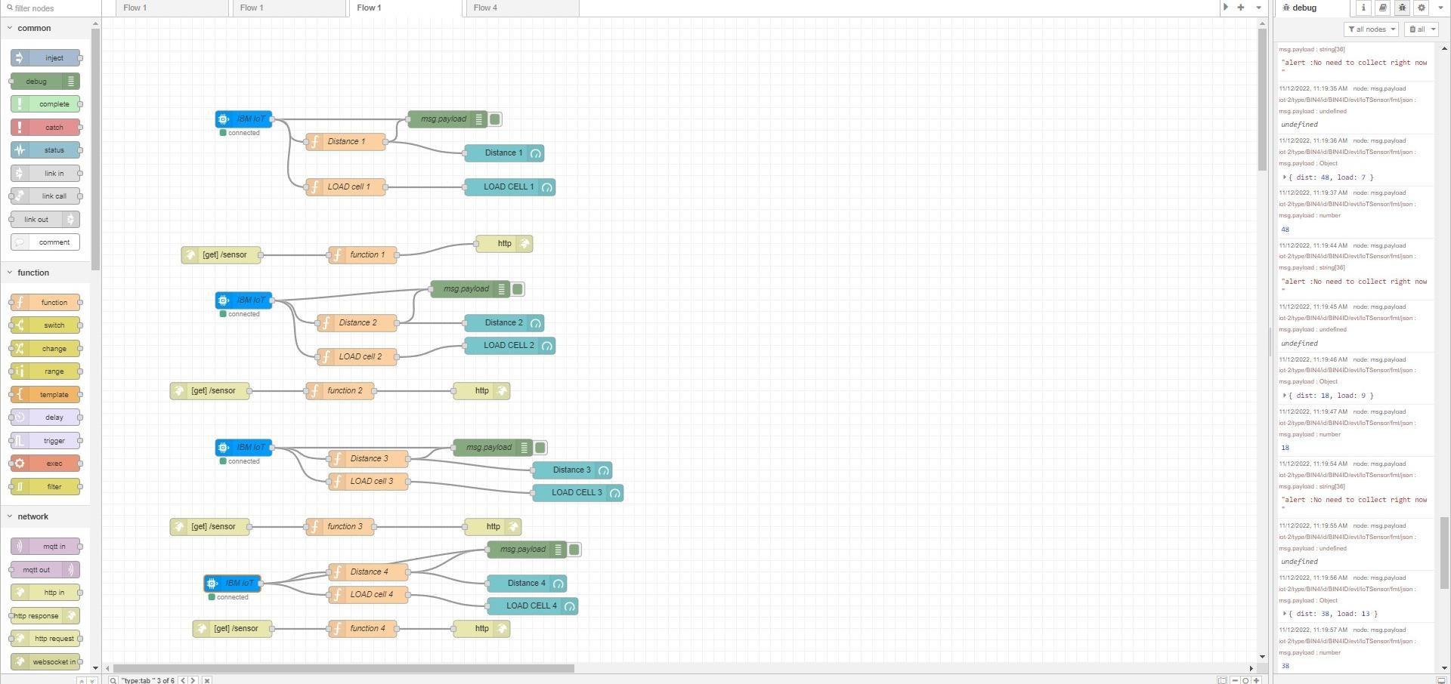Node Red Flow:

Node RED-UI

